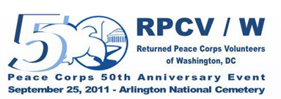

RPCV/W

The Returned Peace Corps Volunteers of Washington D.C. (RPCV/W) was founded in 1979 and incorporated in 1990 in the District of Columbia. RPCVw is one of the largest organizations of its kind in the world. RPCV/W is a nonprofit 501c3 with over 500 members and representing more than 2,500 returned Peace Corps volunteers, Peace Corps staff, and Peace Corps families and supporters in the greater Washington D.C. area. RPCV/W is governed by an elected board of directors.

MISSION & VISION:

By fostering opportunities to share our unique experiences and commitment to service, we create a community that celebrates the diversity of the greater Washington area and world cultures.

GOALS:

- Undertake and sponsor educational and charitable activities in support of the Peace Corps 3rd Goal of “Helping promote a better understanding of other peoples on the part of Americans;
- Inform and educate members and the public on matters relating to economic development and developing countries, including but not limited to those countries which have been served by the Peace Corps;
- Support policies to maintain a strong and healthy Peace Corps;
- Encourage continuing volunteer involvement of its members in serving the needs of their local communities;
- Affiliate and strengthen other organizations with similar vision and mission goals, such as the NPCA; and
- Provide the foundation of a Community of Returned Peace Corps Volunteers to support all of the above activities

RPCV/w
P.O. Box 66101
Washington, D.C. 20035
Event Day Contact Information

Arlington National Cemetery
Visitors Center
Arlington, Virginia 22211
(703) 607-8585

Main RPCV/W 50th Anniversary Contacts:

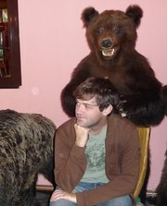
Jason Smith – Chair, Arlington 50th Committee & Performance Coordinator
202-603-0956

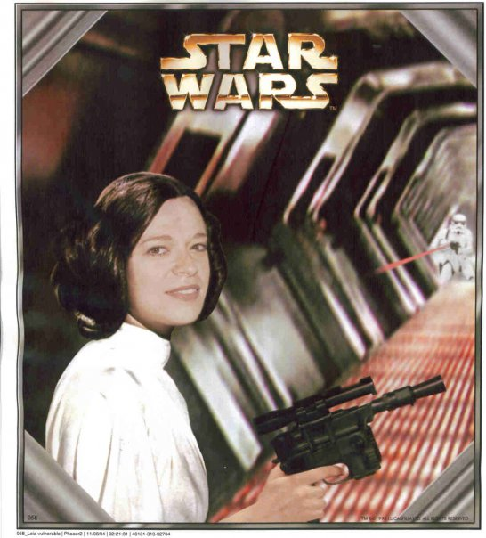
Laara Manler – Chair, Arlington 50th Committee & Logistics Coordinator
571-332-3470

Chris Robinson,
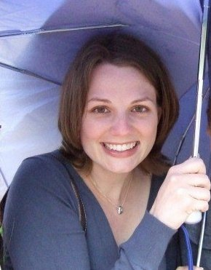
Walk of Flags Logistics Coordinator
703-994-7685

INFORMATION – Safety & Security & Respect

As in any emergency, your first point of contact is 911

Accident / Emergency Procedure: if there is an emergency, please follow these steps

- Call 911
- If you see a park ranger or other Arlington Cemetery staff member, alert them to the situation
- Call the visitors center and alert them to the fact that you have called 911 and are awaiting an ambulance 703-607-8585


T-shirts: Please wear your Volunteer T-shirt on Event Day to identify yourself to both Cemetery Staff and Event Guests


Cell Phones:

- Exchange numbers with your volunteer partner
- Please change any ringtones that may be inappropriate in a Cemetery setting
- Silence your phones before arriving at the Amphitheater or 5 minutes before the start of the event
- If you know you are “on-call” or might be needed to be reached by friends, colleagues, or family, sit close to an exit and excuse yourself to take the call


Appropriate Dress:

- Though it may be a warm summer’s day, please remember that we are all guests at Arlington National Cemetery and it is a work cemetery where people come to honor fallen family, friends and American heroes
- Please ensure that you wear comfortable shoes as most of you will be on your feet for several hours
- Ensure you bring all those things that you may need to ensure your own safety and security (sunscreen, sunglasses, and any medications that you may need)

Be Prepared:
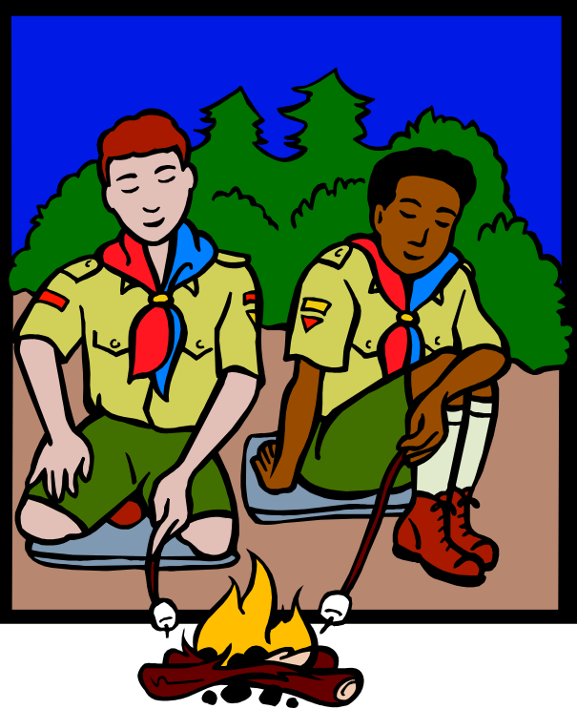
- Please be prepared for the weather - check the local forecast and be prepared for whatever the day may bring
- It is imperative that you wear comfortable shoes, no matter what your post. Most of you will be on your feet for several hours prior to the start of the ceremony!
- Please remember to call your team captain if there is any change in your availability or if you know that you will be late
- Please remember to check the metro web page (www.wmata.com) so that you are aware of any interruptions in service for that day and plan accordingly
- If you plan to drive and park your car – please review the costs involved for parking at Arlington as it is not free and plan to arrive early as parking is limited

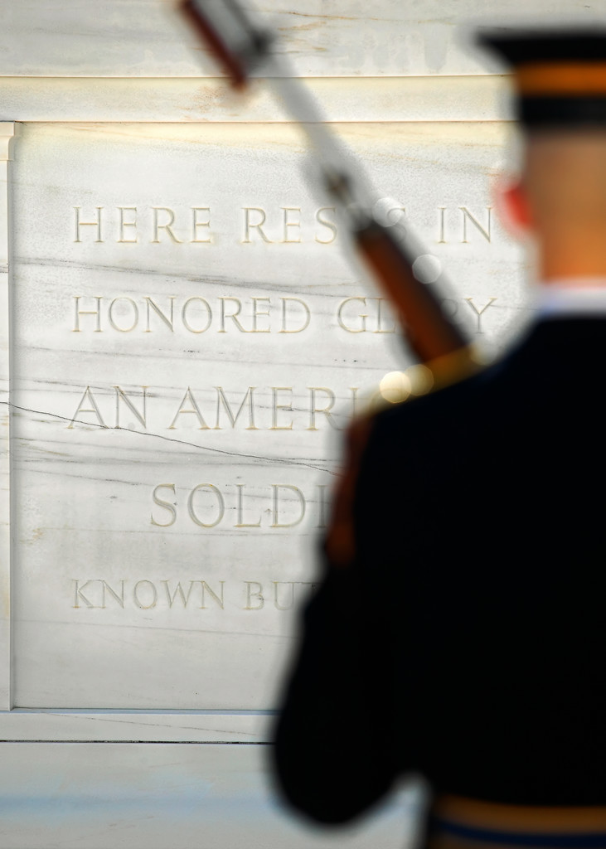
Event Day:

- Please plan to arrive on time!
- Check in with your team captain and then report to your post
- Please ensure you have all of the following:
- copy of the program (to answer questions, guests will receive one when they arrive in the amphitheatre)
- several maps of the cemetery to hand out as needed
- your phone and the phone number of the team captain and your volunteer partner (please change your ring tone so it is not too disruptive to other visitors especially those visiting the gravesites of loved ones)
- a plastic bag to dispose of any items guests have brought that are prohibited (water bottles, food)
- Know the layout of the cemetery from the Visitor’s Center to the amphitheater –and be prepared to answer questions such as:
  - Location of closest restroom to your post
  - The route to the JFK grave site
  - How much further from your post to the amphitheater
  - How long program will last and how many minutes (from any point asked) until it begins.
  - Know the cost and operating schedule of the Tourmobile
- PLEASE REMEMBER THAT IN ANY EMERGENCY YOU SHOULD DIAL 911 FIRST then
  - Inform your team captain
  - Inform the nearest park ranger or cemetery official or in lieu of that call the visitors center information desk and notify them
- If you are planning to volunteer or participate in the walk of flags or watch the ceremony at the amphitheatre, please be sure to give yourself enough time to get where you need to be but do not leave your post without first notifying your team captain.
Other Helpful Information
If you live outside of town and want to be closer to Arlington in order to arrive in time to report to your post on Event Day, consider NPCA’s Hospitality Network.
NPCA Hospitality Network: If you are seeking ”couch surfing” opportunities, check out the Couch Surfing / Hospitality group in the NPCA online community. Create a profile and visit the group to plan your stay in Washington, DC. http://community.peacecorpsconnect.org/main/authorization/signIn?target=http%3A%2F%2Fcommunity.peacecorpsconnect.org%2Fgroup%2Fcouchsurfing

Speaker / VIP Pictures & Bios

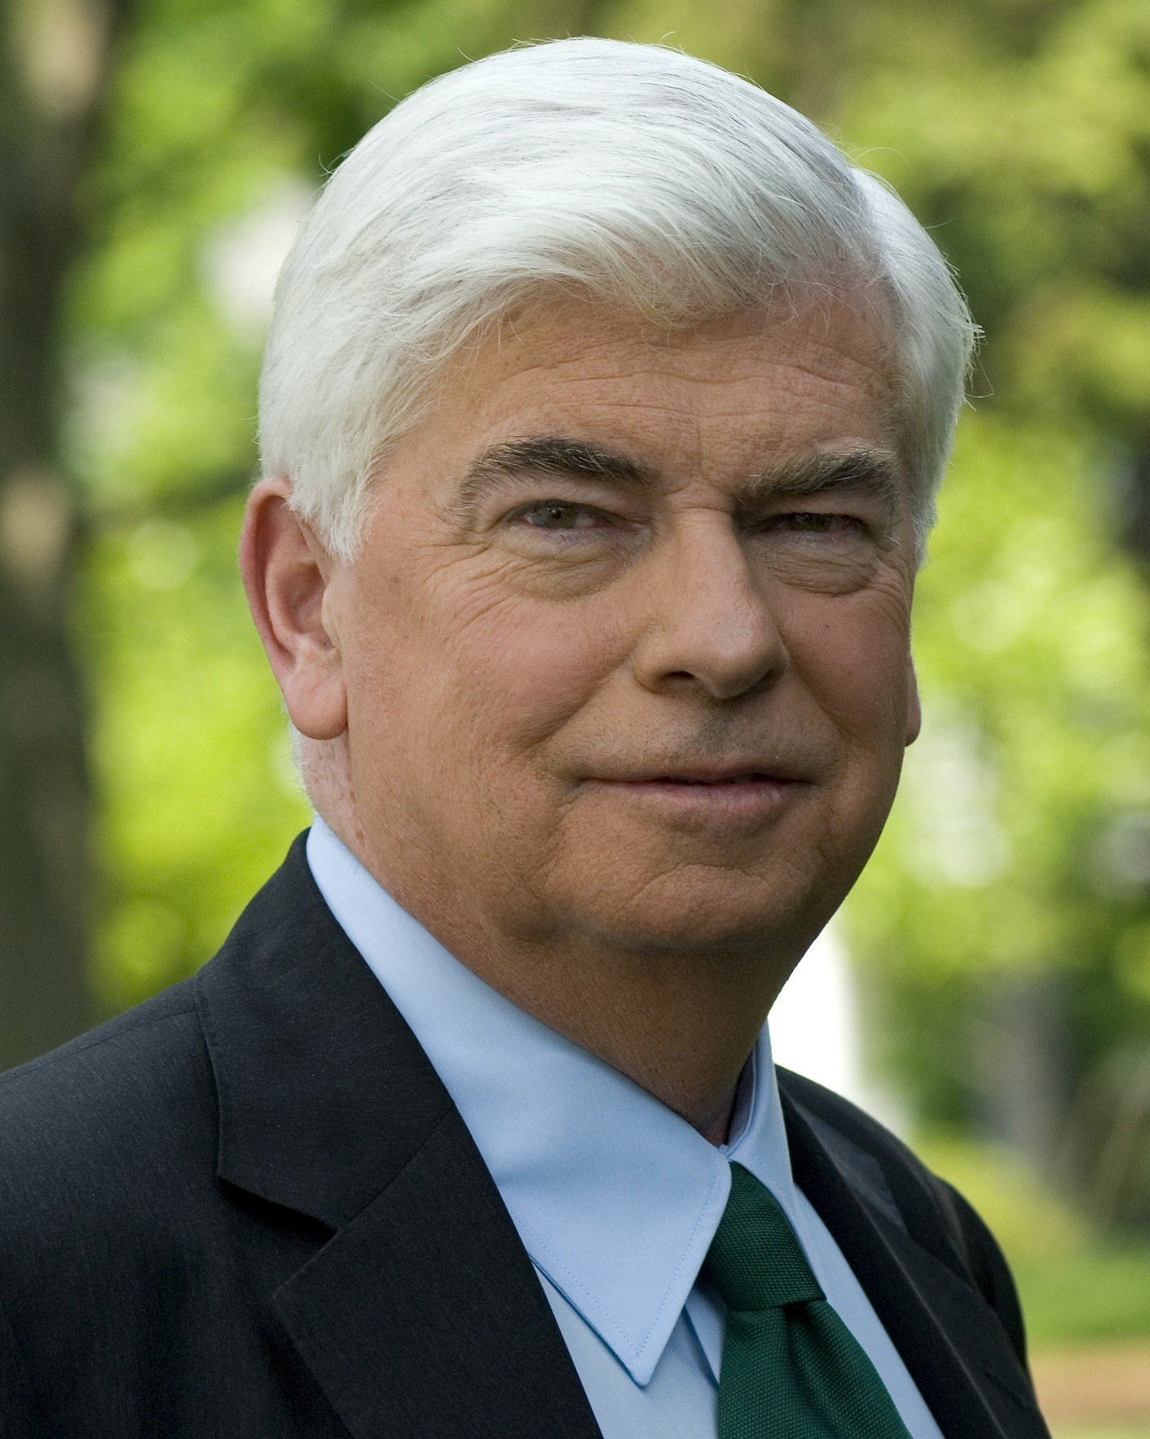
Chris Dodd - Currently the head of the Motion Picture Association of America, Senator Dodd served as a Peace Corps Volunteer in the Dominican Republic village of Monción from 1966-68. After joining the US army reserve, Dodd served in the United States House of Representatives from 1974-1980 representing Connecticut’s 2nd Congressional District. In 1980 he won a seat in the United States Senate and served five terms. During his time in the Senate, Dodd was a major supporter of increasing and improving the Peace Corps and in 2010 was awarded the Peace Corps Champion Award by the Returned Peace Corps Volunteers of Washington, DC.

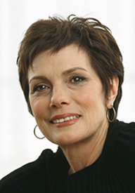
Maureen Orth - Master of Ceremonies Maureen Orth began her journalism career at Newsweek, and became principal correspondent of Newsweek Woman on Lifetime TV. Her distinguished career includes network correspondent for NBC News, contributing editor of Vogue, columnist for New York Woman, and author of 2 bestselling books. Ms. Orth served as a Peace Corps volunteer in Medellín, Colombia, where she helped build Escuela Marina Orth, the first school in Colombia participating in the One Laptop per Child project. Ms. Orth formed the K12 Wired Foundation in the U.S. and Fundacion Marina Orth in Colombia. She is currently working with the Colombian Coffee Growers Federation and the city of Medellin on a new program for former Peace Corps volunteers to return to Colombia to support the coffee growers.
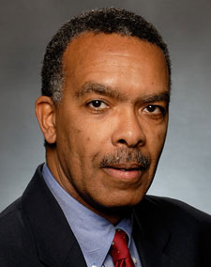
Aaron Williams - Peace Corps Director Aaron Williams served as a Peace Corps volunteer in the Dominican Republic from 1967-1970. After Peace Corps, he coordinated minority recruitment for the Peace Corps in Chicago. His careers has focused on international development, including vice president for International Business Development with RTI International, senior manager at USAID, where he attained the rank of Career Minister in the U.S. Senior Foreign Service, and executive vice president of the International Youth Foundation. In 2009 he was sworn in as the eighteenth Director of the Peace Corps and only the fourth director to have served as a Peace Corps volunteer.

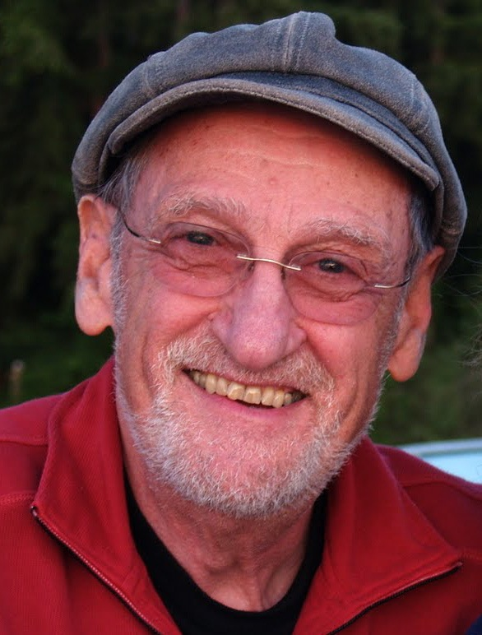
Al Guskin - An alumnus of the University of Michigan, Mr. Guskin was a leader of the Americans Committed to World Responsibility, the student group credited with inspiring President Kennedy to move forward with establishing the Peace Corps. In 1961 he joined the Peace Corps staff in Washington, DC and in 1962, Mr. Guskin and his wife Judith joined the Peace Corps as volunteers in the first group to go to Thailand. After Peace Corps, Mr. Guskin went on to receive a PhD in Social Psychology from the University of Michigan and pursued a life of academia, including serving as chancellor of Antioch University.

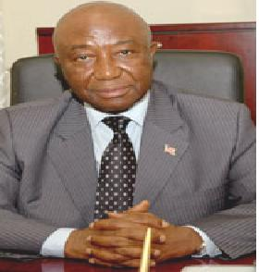
Joseph N. Boakai Sr. - Vice President of Liberia, Mr. Boakai was influenced by Peace Corps volunteers at an early age. Born in the remote village of Worsonga in the Foya District, Mr. Boakai came from humble conditions to pursue a 37 year career in business and government, including serving as Chief Executive Officer and the first Liberian Resident Manager of the Liberia Produce Marketing Corporation, Managing Director of the Liberia Produce Marketing Corporation, Managing Director of the Liberia Petroleum Refinery Company, and Minister of Agriculture. A graduate of the University of Liberia where he studied Business Administration, Vice President Boakai has completed studies in Grain Storage and Marketing from Kansas State University and received an Advanced Management Certificate from Ghana.

